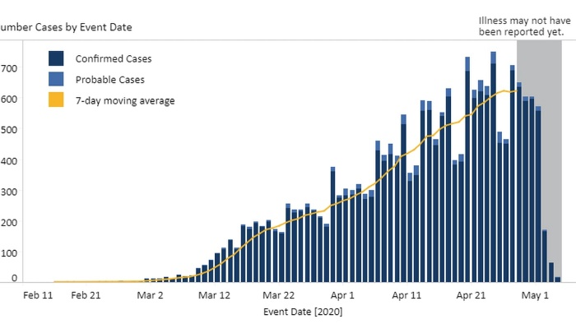Elijah Rathke
Documenting Your Experiences
This year, 2020-2021 has been a sure rollercoaster ride for everyone. Personally, I did not mind going to school twice a week with three online, hybrid days. Overall, this is not how I expected my sophomore year of high school to go, but it is a year I cannot forget. School online was very challenging. For instance, I had a C+ in a class I had 100% online, and then when we made the switch to coming back four days a week, I now have an A. It’s almost hard to believe that I haven’t had a full year of high school yet, and I will be a junior next year. It honestly sucks and growing up sucks. The year has taught me many things, but most importantly, time management is a key factor in a lot of things we do. With over ¾’s of the year being hybrid, or two days a week it was hard to get everything done. When you’re at home, you aren’t thinking about school. After Tuesday, I immediately thought about what I should do with friends, and completely forgot about school until Sunday night. I would cram in a lot of homework on Sunday night’s, and it was hard to give 100% to every assignment when I would be tired and wanting to go to bed. That was one thing I wish I could go back and redo because with better time management and effort I could have had better grades. COVID-19 has caused a lot of disagreement and separation between political parties. The masks have turned into political warfare. Many people like myself, would say wear it if you want to, what other people decide on doing should not affect what you do. Another thing that took a huge toll on everyone was our quarantine for a couple of months. When everyone was locked inside their homes, many people gained bad habits such as being lazy, not exercising an appropriate amount, etc. My personal experience from that quarantine was decent. I played a lot of video games with my friends, and just hung out with close friends occasionally. Nobody really knew the severity of the virus; I think a lot of people just wanted to take safe protocols in case it were worse than we thought. Overall, COVID did not have many benefits for the people, but has taught a lot of life lessons.

I chose a journal entry as my primary source because I felt like this way, I could easily express my thoughts and feelings on the COVID-19 pandemic. This journal entry best expresses my experiences during the pandemic and was an easy way for me to explain them. This journal entry is considered a primary source because it is written from a student in high school during this pandemic. I think future historians, researchers, and students can learn from this in case it happens again, they have a little input on how the students feel about pandemics and how they should run schooling in case it happens again. When we learned about the Spanish Flu, it had a lot of relation to our global pandemic, COVID-19 today. The Spanish Flu had quarantine stations which was new to me and is no longer a thing today.

