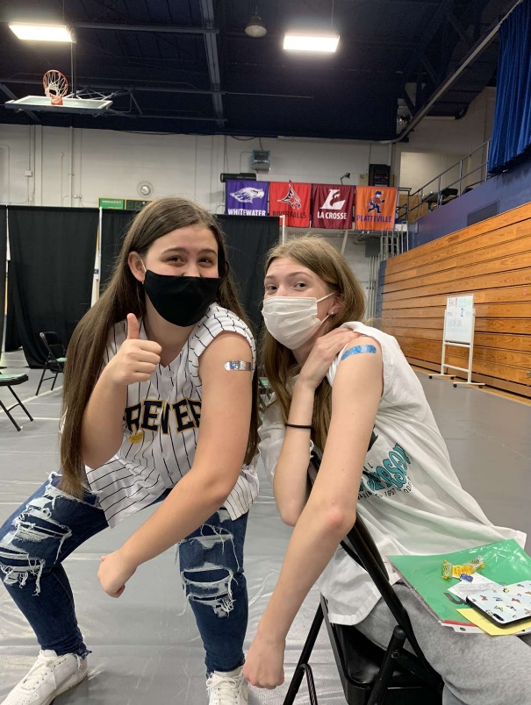
I chose this picture to represent my experience through Covid because it is close to my heart. To have a visual reminder that I am helping protect not only myself, but others with the vaccine. While I was getting my vaccine, I happened to see my friend Morgan getting hers at the same time! We were both very excited that we could finally get the vaccine, since before only 16-year-olds and up were allowed. We took a picture to commemorate the time we got vaccinated for Covid. This is a primary source because it documents my personal experience from the pandemic in the form of a photo. I think that this picture can really represent what it was like these past years because people can look at it and see how happy it really made some people to be able to fight against the virus. The pandemic hit everyone hard, we did not get to see our family and friends, live the lives we wanted these past years, and loved ones were lost. But through the dark time there were also times like this one where we could finally have something to smile and be proud about. This relates to historical work from the past because it gives a look into what life was like to others who maybe did not live through the pandemic.

