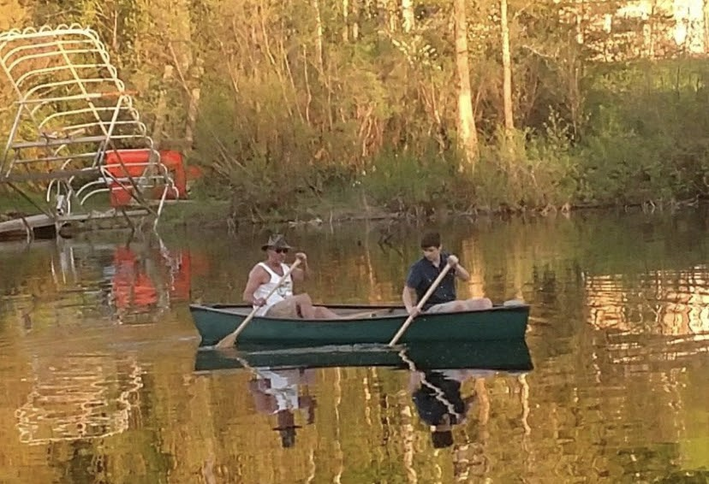

Covid-19 has been awful. Lives have been lost, schools have been shut down, local businesses have closed, and political controversy has been more wild than any other year that i’ve been alive. But being on the lake, with my grandpa, away from society was one of my coping mechanisms throughout the summer of the pandemic. It was almost like a break from the real world, which was well needed.

