How Covid-19 affected us in 2020-2021
Karissa Statz
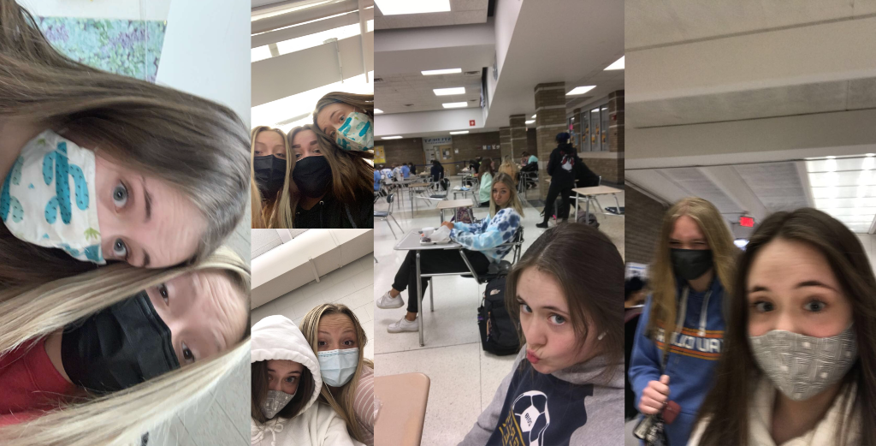
I chose to write a kind of report/blog because it was the best way I could describe my experiences in the pandemic. Covid-19 affected all of us differently and taught us valuable lessons and we had different experiences. Covid-19 started about mid 2020 and caused us to be quarantined or in lockdown. Schools were closed, schools were closed, restaurants, fast food, dentist offices, etc. Everything seemed to have gone still and everyone was freaking out. We all had to do school virtually either joining team meetings or reading notes or watching a video. We had to learn a different way and had to figure out stuff on our own sometimes. Eventually when we HAD to go to the grocery store for food we would have to wear masks and stay far away from people or even wait in a line outside so we could get in after people left. Life changed so much and we all were shocked and startled by this new disease coming into our country. We were all terrified of what if we got it or if we would ever go back to normal. We had an extended summer pretty much starting when we went into quarantine. We had barely any assignments and it was a pass or fail grading system. I feel like a lot more people then got the chance to spend more time outside and explore and go on walks and bike rides and had the chance to be more active. Well you know summer eventually comes to an end and school came around the corner and where I go to school they changed it up alot. The school was split into Cohort A, B, and C. Cohort A was going to in-person school Monday-Tuesday and was virtual Wednesday-Friday. Cohort B was going to in-person school Thursday-Friday and was virtual Monday-Wednesday. Cohort C was then students who chose to be all virtual or could not come to in-person school so they did all virtual learning. It stayed like this for almost the whole school year until May 3rd when Cohort A and B came back in person the whole 5 days besides Wednesday. When we all came back in person it was very weird and different because we felt like we never had that big of a class before when normally we are this big besides Cohort C not being here. We still had to try to social distance and wear masks but it’s hard with as many people as we have. Other than school there is a lot more but school was a big part and a huge effect on K-12th grade and especially college students as well.
I believe people could learn and take from this resource that the Covid Pandemic was rough and life changed but good still came out of it and we are slowly going back to normal. This relates to previous documents I've seen in this class because it shows what life was like during the pandemic and it shows how it affected us and what changed and how we can reflect on how we managed this pandemic.

